January 20th, 2008
Hi
Last Sunday the cold front arrived – again, one day too late for my run! This has happened many times! Also watched (and recorded) a TV documentary about climbing Everest (to honour Hillary). Then when I was mucking around with the recording, it was deleted! However, the programme was repeated again the next day so recorded that though it was only 1 hour long instead of 2 hours.
On Tuesday, there was a regular 3-4 monthly cleaning of suite in the afternoon when they do more than the regular cleaning, such as shampooing the carpet and washing the curtains (at least the thin white curtains). So I went to the gym while that was carried out.

Heard on the news that that US is to get milk from cloned cows. They say it is OK but there is always some doubt given the blunders of the past when things were supposed to be safe.
As mentioned in my separate e-mail Gavin, the two DVDs you sent arrived. I have not viewed them yet but will do so soon. Further to my comments about NTSC v PAL, I read that DVD players using the PAL system will also play NTSC recordings but not vice versa. So if I sent a DVD from here (recorded in the PAL system) to you, it would not play properly.
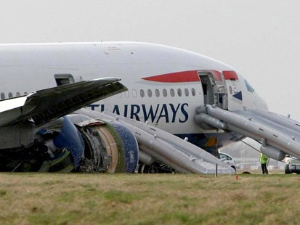
There has been a lot in the news on the crash of the British Airways 777 at Heathrow airport the other day. In fact, I flicked onto the BBC channel and found that they were giving a continuous broadcast of the crash. I guess you too have heard about it. The plane lost all engine power (though the engines were still idling) at just 600 ft and 2 miles from the airport. and from all accounts, the pilot did a remarkable job gliding the plane down. With many other airlines, the plane would not have made it to the airport resulting in a major disaster. As the pilot later said, they have drills for such a situation at 30 000 ft but not 600 ft. This is what happened about 20 years ago when an Air Canada dead B767 ran out of fuel (when the fuel was added, it was measured in litres and not gallons!!) and the pilot managed to glide the plane down onto a back country airstrip that fortunately was located ahead of them. The other scary thing about the 777 is that it uses ‘fly by wire’ and relies heavily on computers to control it.
For the run yesterday, the weather was cool – the cold front had arrived earlier this time. It was about 10⁰C cooler than last week. Ran up Needle Hill. I was going to take a shortcut but eventually did the whole route – at 2 hours 57 minutes, the time was the same as last year, though 5 minutes off my best. One unusual thing was the very large number of people out hiking. There must have been 200 people, many of them in large groups also climbing Needle Hill.
That’s about it for now.

Cheers

